**CENWP-OD-B 05 July 2022**

**MEMORANDUM FOR THE RECORD**

**SUBJECT: 22BON030 MFR AFF Sockeye Mort**

The U.S. Army Corps of Engineers is reporting on the incident reported by Columbia River Inter-Tribal Fish Commission (CRITFC) and the potential impacts to fish and/or fish passage conditions at Bonneville Lock & Dam. This incident is not the responsibility of the Corps. We report it here for regional awareness.

On 05 July, Columbia River Inter-Tribal Fish Commission (CRITFC) Biologists notified Bonneville Project Biologists of a sockeye mortality found in the brail pool of the Adult Fish Facility (AFF). The sockeye was sampled and tagged earlier that morning by CRITFC. The fish was scanned for PIT tags, inspected, and returned to the river.

1. Species – Sockeye (*Oncorhynchus nerka*)
2. Origin – NA
3. Length – approximately 49.5 cm
4. Marks and tags – Unclipped adipose, caudal fin punch, and Tag: 3DD.003DEAB2F7
5. Marks and Injuries found on carcass – No visible injuries
6. Cause and Time of Death – Unknown time on 05 July, discovered in brail pool after sampling.
7. Future and Preventative Measures – None

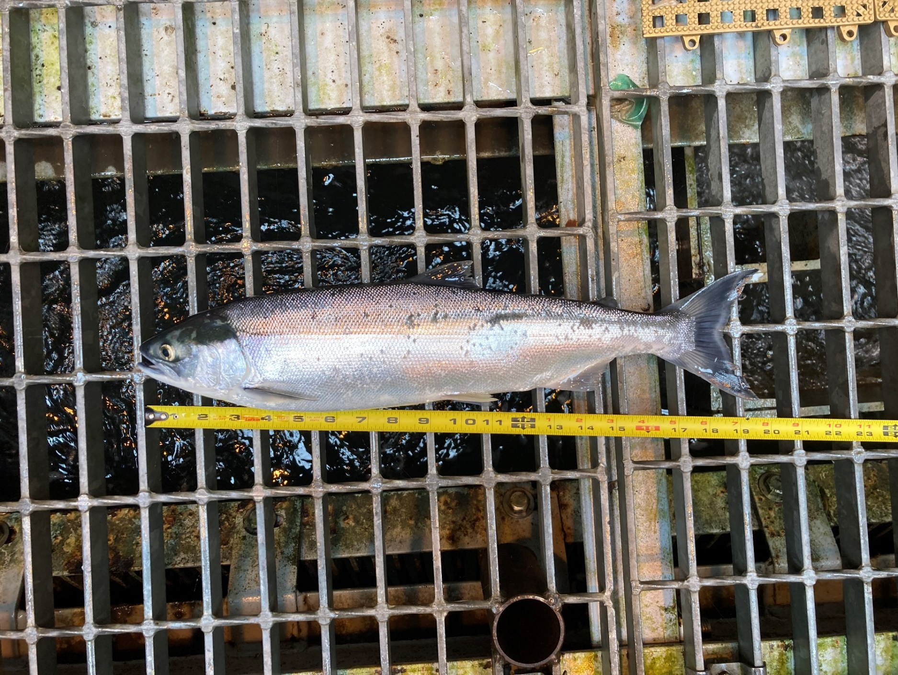

Sincerely,

Bonneville Project Fisheries